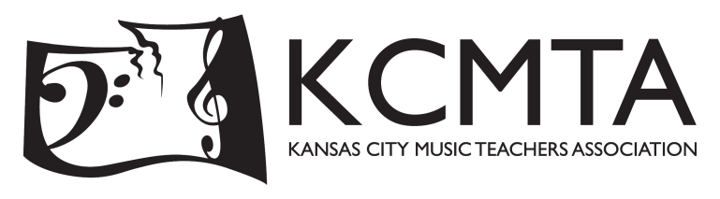

June 6, 2022

Dear Fellow Arts Patron,

An audience of nearly 400 arts-minded families is waiting to hear from you!

On January 8, 2023, the Kansas City Music Teachers Association will present an exciting musical experience to our community – the 27th Multi-Piano Concerts, “Reflections of America”. These two concerts feature duet teams performing as a piano orchestra on 12 grand pianos under the direction of professional conductor Chad Reed. Representing the entire metropolitan area, students play alongside siblings, friends, teachers, parents, and even grandparents.

For KCMTA, a non-profit 501 c-3 corporation, this is the most “public” of our organization’s offerings. Large-scale offerings such as the Multi-Piano Concerts demand large-scale funding. An event of this size would be impossible without the financial support of our community.

Our performers are required to be backstage half an hour before the concert begins. That means most families will be in their seats for 30 minutes before the concert. This gives you the opportunity to reach a truly “captive” audience!

KCMTA would like to offer you an opportunity to advertise your business to our performers and families in one of three ways:

- In our Multi-Piano Concert program
- On projector space for viewing before and after both concerts
- In both the program and on projector space (for a 25% discount)

Program space rates:
- Full page (5.5” X 8.5”)_____________________ $100.00
- Half page ________________________________$ 80.00
- Quarter page _____________________________$ 50.00

Projector space rate:
- 3 slides before and after both concerts for a total of 12 viewings: $100.00

Thank you for your consideration and support of these unique concerts!

Sincerely,

Heather Lewis
KCMTA Multi Piano Chair
Mom4casey@yahoo.com

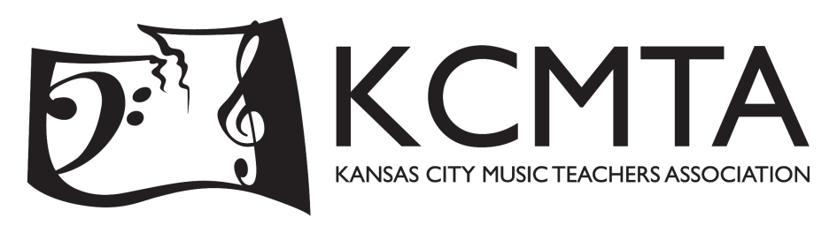

MULTI-PIANO CONCERT ADVERTISING ORDER FORM

Company, organization or individual as it is to appear in the program and on the screen:

_________________________________________________________________________________________

Program space:
Full page (5.5” X 8.5”)_______________________$100.00 ________
Half page__________________________________ $ 80.00 ________
Quarter page_______________________________$ 50.00 ________

Projector space:
3 slides before and after both concerts for a total of 12 viewings: $100.00 ________

Combination of your choice of program ad and projected ad:
25% discount on the total amount. - ________

TOTAL: ________

Ad files may be submitted digitally, in PDF format, ksupianomom@gmail.com. Printed ads will appear in black and white, projector ads may be submitted in black and white or color. For formatting or submission questions, please email Linda Featherston at ksupianomom@gmail.com.

The advertising deadline for the 2023 program is December 1, 2022.

Checks should be made payable to Kansas City Music Teachers Association and mailed to:
Linda Featherston
11007 W 100th St
Overland Park, KS 66214

Thank you for your generous support of the 2023 Multi-Piano Concerts, KCMTA, and our students. We appreciate your support of this enriching opportunity for our youth.

